## MEDS - Bridging Surplus to Need, Reducing Waste

Submitted in partial fulfillment of the requirements of the degree

**BACHELOR OF ENGINEERING IN COMPUTER ENGINEERING**

By

**1. Hemant Shankar Satam (56)**

**2. Harsh Laxman Patil (50)**

**3. Gaurav Nirmal Gupta (26)**

**4. Suryanarayan Santoshkumar Panigrahy (47)**

Name of the Mentor

**Prof.**  **Dr. Rohini Temkar**

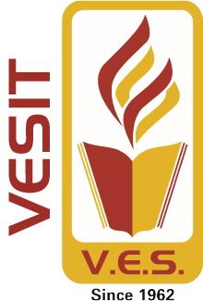

# Vivekanand Education Society’s Institute of Technology,

**An Autonomous Institute affiliated to University of Mumbai**

# HAMC, Collector’s Colony, Chembur,

**Mumbai-400074**

**University of Mumbai (AY 2024-25)**

# CERTIFICATE

This is to certify that the Mini Project entitled **“MEDS - Bridging Surplus to Need, Reducing Waste”** is a bonafide work of **Hemant Satam (56), Harsh Patil (50), Gaurav Gupta (26), Suryanarayan Panigrahy (47)** submitted to the University of Mumbai in partial fulfillment of the requirement for the award of the degree of **“Bachelor of Engineering”** in **“Computer Engineering” .**

## (Prof. Dr. Rohini Temkar)

Mentor

## (Prof. Dr Nupur Giri) (Prof. Dr. J.M. Nair)

Head of Department Principal

# Mini Project Approval

This Mini Project entitled “**MEDS - Bridging Surplus to Need, Reducing Waste”** by **Hemant Satam (56), Harsh Patil (50), Gaurav Gupta (26), Suryanarayan Panigrahy (47)** is approved for the degree of **Bachelor of Engineering** in **Computer Engineering.**

**Examiners**

1. **Dr. Rohini Temkar**

(Internal Examiner Name & Sign)

## 2…………………………………………

(External Examiner name & Sign)

Date:

Place: **VESIT, Chembur**

# Contents

## Abstract 4

## Introduction 5

* 1. Introduction
  2. Motivation
  3. Problem Statement & Objectives
  4. Organization of the Report

1. **Literature Survey 7**
   1. Survey of Existing System
   2. Limitation Existing system or Research gap
   3. Mini Project Contribution

## Proposed System 10

* 1. Introduction
  2. Architectural Framework / Conceptual Design
  3. Algorithm and Process Design
  4. Methodology Applied
  5. Hardware & Software Specifications
  6. Experiment and Results for Validation and Verification
  7. Result Analysis and Discussion
  8. Conclusion and Future work.

**Abstract:**

The Meds project is focused on creating a medicine exchange and distribution platform using Flutter to address prescription medication waste while enhancing accessibility for individuals in need. Leveraging the cross-platform nature of Flutter, the app allows users to safely donate, sell, or exchange unused medications. To optimize redistribution, machine learning algorithms analyze real-time demand and supply data, ensuring medications are efficiently directed to those who need them most. This approach not only reduces medication waste but also minimizes environmental impact by preventing improper disposal. The user-friendly interface offers a seamless experience for donors, sellers, NGOs, and individuals seeking medications. The platform is built with a strong emphasis on safety and compliance, partnering with NGOs and pharmacies to verify medication quality. By integrating secure transactions and incentive mechanisms, Meds promotes community-driven participation and fosters healthcare sustainability. With machine learning-driven price optimization, the app ensures fair pricing while improving accessibility for underserved communities. This project represents a novel solution to medication management, enhancing both public health and environmental responsibility through technology.

1. **Introduction**

**1.1. Introduction**

An NGO-operated marketplace, in partnership with a reputable pharmacy and powered by machine learning, provides a solution to reduce waste and enhance access to essential medications. It lets users sell or donate unused medicines, with machine learning algorithms optimizing prices based on real-time demand and supply, ensuring fair pricing and efficient distribution.Initially unconventional, selling or donating leftover medicines is gaining acceptance due to technological advances and a focus on sustainability. Machine learning represents a significant shift in medication management, helping to prevent waste. The NGO-pharmacy collaboration ensures high safety and integrity standards, providing a reliable and effective system.

**1.2. Motivation**

This project is guided by four key principles:

1. Minimizing Medication Waste: Reducing the waste of unused prescription medications through effective redistribution.
2. Enhancing Accessibility: Improving access to essential medicines for underserved communities.
3. Encouraging Donations: Motivating users to donate surplus medications, fostering a community-driven approach to healthcare sustainability.
4. Leveraging Technology: Using Flutter and machine learning to optimize and streamline the medicine exchange and donation process.

These principles collectively support sustainability, healthcare access, and technological efficiency in the donation and distribution of medications.

**1.3. Problem Statement and Objective**

**Problem Statement**

A significant amount of prescription medication is wasted due to side effects, early recovery, or excess purchase, leading to financial loss and environmental harm. Patients often discontinue medication because of adverse side effects or early recovery, leaving unused drugs. Over-purchasing also contributes to this waste. This represents a financial loss for individuals and healthcare systems and poses environmental risks due to improper disposal. Meanwhile, many people struggle to afford necessary medications, highlighting a need for better medication management and redistribution solutions to improve accessibility and reduce waste.

**Objective**

1. Develop a Flutter-based medicine exchange and distribution platform to minimize prescription medication waste and enhance accessibility for individuals in need.
2. Implement machine learning algorithms to optimize medicine redistribution by analyzing real-time supply and demand, ensuring efficient and fair distribution of unused medications.
3. Provide a secure and user-friendly interface that allows users to easily donate, sell, or exchange surplus medications with transparency and reliability.
4. Collaborate with NGOs and pharmacies to ensure safe handling, verification, and compliance with legal standards in the redistribution process.
5. Encourage community participation by offering incentives to users who donate medicines, fostering a sustainable and socially responsible healthcare system.

**1.4 Organisation of the Report:**

The report is structured as follows: It begins with an introductory section that outlines the motivation, problem statement, and objectives of the study, along with an overview of the report's organization. The subsequent section conducts a thorough literature survey, examining existing systems, highlighting limitations or research gaps, and discussing the contributions made by the mini project. The core of the report focuses on the proposed system, introducing a new approach to data summarization. This section covers the system's architecture, algorithm design, hardware and software details, and presents experimental results. It concludes with a summary of findings and outlines future work. This organized structure ensures a comprehensive exploration of the research and project.

**2.LITERATURE SURVEY:**

**2.1 Survey of Existing System:**

| **Sr.**  **No.** | **Name of**  **Research paper** | **Reference** | **Summary of**  **Research Paper** |
| --- | --- | --- | --- |
| 1 | **Optimization of Dynamic Pricing in E-Commerce with Demand Side Management using Fuzzy Logic System** | **S. Shukla, Y. Kharde, G. N. Mandala, S. Bhikaji Jadhav and G. S. Doguparthy[1]** | The paper proposes a fuzzy logic-based optimization framework for dynamic e-commerce pricing to address demand uncertainties, aiming to increase sales and customer satisfaction.  Using fuzzy logic in demand-side management enhances pricing strategies, boosting revenue and customer experience in e-commerce. |
| 2 | **Management of medicines Wastage, Returned Medicines and Safe disposal in malaysian community pharmacies: A qualitative studies** | **Chong Kah Mun , Rajiah Kingston , Chong David , Maharajan Mari Kannan[2]** | This study examines how Malaysian community pharmacists handle medication wastage, returned medicines, and safe disposal, noting their positive perceptions and challenges faced.  Pharmacists seek to reduce medicine wastage and emphasize that greater public awareness and government support are crucial for successful return programs. |
| 3 | **Implementation Augmented Intelligence on Drug Inventory Management Forecasting** | **N. A. Satrio et al.[3]** | The study develops an augmented intelligence system using a stacked LSTM model for drug inventory forecasting in hospitals, achieving high accuracy in predictions.  The stacked LSTM model outperforms other models, making it the most effective for drug inventory forecasting with high R2 and low MSE and MAE values. |
| 4 | **An optimal system of recycling unwanted medicines by sustainable synergy of drugmakers, drugstores, customers and governments** | **Yufeng Luo, Zhong Wan[4]** | The paper presents a sustainable system for recycling unwanted medicines, integrating key stakeholders and achieving a 24.7% profit margin and over 50% recovery ratio.  An efficient algorithm optimizes this system, enhancing sustainability and profitability through existing sales networks. |
| 5 | **Inventory Management and Control Of Deteriorating Pharmaceutical Products Using Industry 4.0** | **A. Mostofi and V. Jain[5]** | The paper examines how Industry 4.0 can improve pharmaceutical supply chain management by addressing drug deterioration through better logistics and data communication.Industry 4.0 tools can reduce drug spoilage and enhance service quality by improving inventory management and production processes. |
| 6 | **Blockchain-Based Verifiable Tracking of Resellable Returned Drugs** | **] M. Debe, K. Salah, R. Jayaraman and J. Arshad[6]** | The document proposes a blockchain system to track and redistribute unused drugs, ensuring safety and reducing waste. It shows effectiveness in managing drug returns and resales, with potential for broader use. |
| 7 | **Knowledge and Disposal Practice of Leftover and Expired Medicine: A Cross-Sectional Study from Nursing and Pharmacy Students’ Perspectives** | **Bashatah, A.; Wajid, S.[7]** | The study finds that pharmacy and nursing students at King Saud University use unsafe methods for disposing of unused and expired medicine, highlighting a need for better awareness.  Improved disposal practices and government guidelines are needed to prevent environmental and health risks among Saudi health care students. |
|  |  |  |  |

**2.2 Limitation Existing System or Research Gap:**

While current systems for redistributing surplus medicines are effective, they face significant challenges:

1. **Medicine Quality and Safety:** Ensuring that donated medications are unexpired and properly stored is a major issue.
2. **Logistical Complexities:** Collecting, sorting, storing, and redistributing medicines involves resource-heavy logistics.
3. **Lack of Financial Incentives:** Most systems rely on donations without offering financial benefits, making them dependent on external funding.
4. **Limited Public Awareness:** There is a gap in knowledge about proper disposal methods, resulting in unsafe disposal practices.
5. **Regulatory Hurdles:** Legal guidelines for medication redistribution complicate operations, limiting the scalability of such solutions.

**2.3 Mini Project Contribution:**

This medicine exchange and distribution platform aims to enhance healthcare accessibility and sustainability by addressing prescription medication waste. Utilizing a user-friendly Flutter interface, it allows individuals to donate, sell, or exchange unused medications, fostering a community-driven approach.

Machine learning algorithms optimize the redistribution process by analyzing real-time supply and demand, ensuring efficient delivery to those in need while minimizing environmental impact. Collaborating with NGOs and pharmacies, the platform prioritizes safety and compliance, promoting responsible medication management. Ultimately, it serves as a vital resource for improving health outcomes and community engagement in healthcare.

3.**PROPOSED SYSTEM:**

**3.1 Introduction:**

We are developing a user-friendly app to efficiently distribute surplus medicines, reducing waste and providing affordable access to those in need. The app includes customized dashboards for donors, sellers, NGOs, and individuals, allowing each user group to manage their activities seamlessly. Machine learning-driven price prediction optimizes the selling prices of unused medicines based on real-time market conditions, while a secure payment gateway facilitates smooth transactions. Donors are incentivized through a point-based system that rewards their contributions. Additionally, NGOs and pharmacies can manage orders, contact donors, and collaborate to meet demand efficiently. To ensure safety and compliance, the app incorporates robust authorization and verification processes for all exchanges, maintaining high standards of authenticity and legality.

**3.2Architecture/ Framework:**

The architecture of the MEDS platform integrates:

* **Frontend:** Developed using Flutter for a consistent user experience across devices.
* **Backend:** Flask server connected to machine learning models for price prediction.
* **Modules:**
  + **User Dashboards:** Separate dashboards for donors, NGOs, and sellers.
  + **Machine Learning Models:** Optimize price prediction based on real-time supply and demand.
  + **Payment Gateway:** Ensures secure transactions.
  + **Incentives Module:** Points-based reward system for donors.
  + **Verification Process:** NGOs and pharmacies handle verification of medicines to ensure quality.

**3.3 Algorithm and Process Design**

**Algorithm:**

1. **Start:**
   1. Initialize variables for user role, current step, and transaction status.
2. **User Registration:**
   1. Prompt users to register or login.
   2. Determine the user's role (NGO, needy individual, or donor).
3. **Dashboard Access:**
   1. Redirect the user to their corresponding dashboard based on their role.
4. **Workflow for NGOs:**
   1. Check Orders: Display pending orders for the NGO.
   2. Verify Medicine Availability: Check if the required medicine is available.
   3. Manage Donations: Process donations and update inventory.
5. **Workflow for Needy Individuals:**
   1. Browse Medicine: Allow users to search for medicine.
   2. Opt for Purchase or Free Application: Provide options for purchasing or applying for free medicine.
   3. Receive Medicine: Coordinate delivery or pickup of the medicine.
6. **Workflow for Donors:**
   1. Post Extra Medicine Availability: Allow donors to list available medicine.
   2. Opt for Donation or Refund: Provide options for donating or requesting a refund.
   3. Send Medicine: Coordinate the delivery or pickup of the donated medicine.
7. **Medicine Verification:**
   1. Send the medicine to a pharmacy for verification.
   2. Update the transaction status based on verification results.
8. **Transaction Completion:**
   1. If verification is successful, complete the transaction.
   2. Update the inventory and transaction records.
9. **Medicine Exchange:**
   1. Facilitate the exchange of medicine between the relevant parties (NGO, needy individual, or donor).
10. **Logout:**
    1. Allow the user to log out of the platform.
11. **End:**
    1. Terminate the workflow.

**Process Design:**

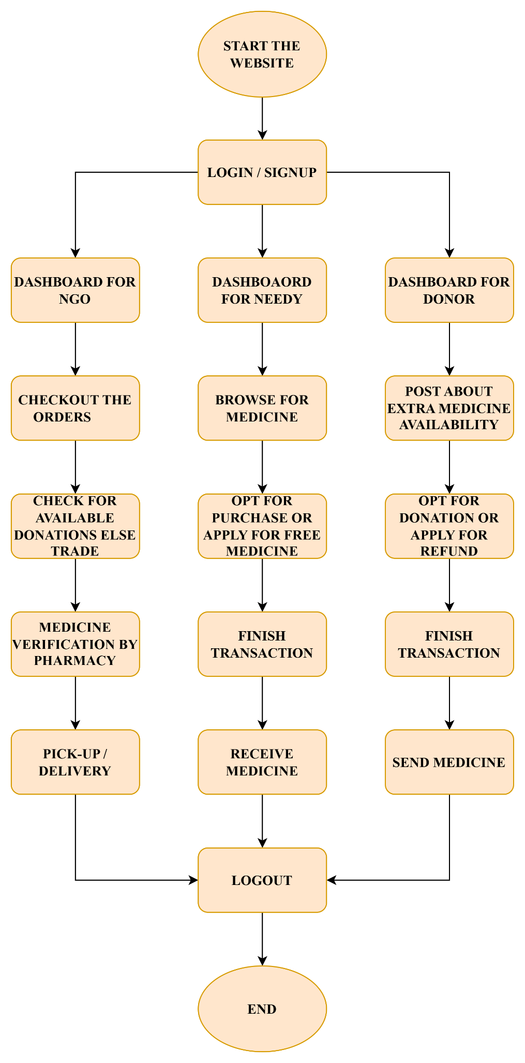

**3.4 Details of Hardware & Software**

**Hardware**

* **Laptop:-**4GB RAM / 256GB ROM
* **Mobile Devices/Tablets**: Interface for medication apps and Android Version is 11+

**Software**

* Front-end Technologies:Flutter for user
* Backend Technologies:Using flask server to connect ML-Model with flutter.
* Text Editors/IDEs: Use tools like Visual studio code (**VS code**) and **Android Studio** for coding.
* We use Github for updating data and getting easily available our data for all.

**3.5 Results**

This project highlights key features that drive efficiency, security, and positive impact in medicine redistribution.

1. **Optimized Redistribution:** Leveraging machine learning for effective pricing and minimizing medicine waste.
2. **Reliable Transactions:** A secure payment gateway facilitated smooth and trustworthy financial processes.
3. **Streamlined Logistics:** NGOs and pharmacies coordinated verification and delivery with efficiency.
4. **Beneficial Outcomes:** Enhanced access to essential medicines while promoting sustainable practices.

**Implementation:**

1. **Role-based Login System:** 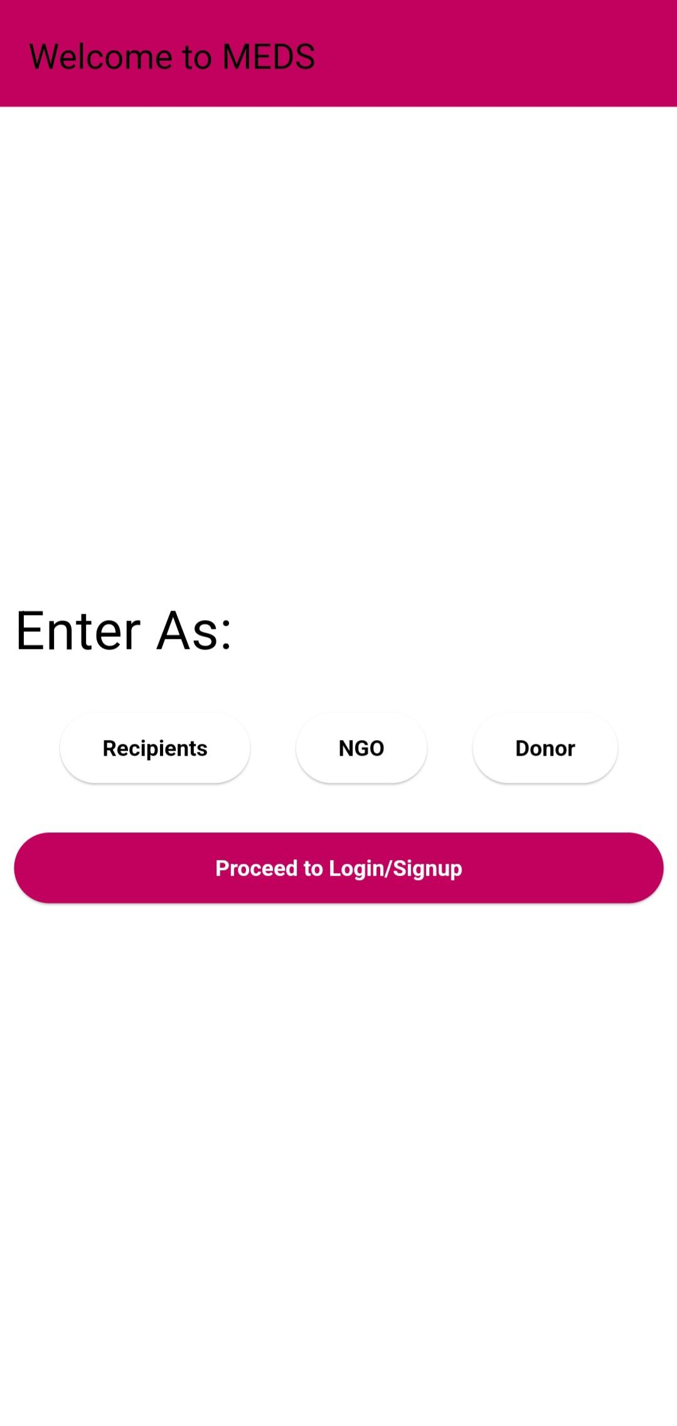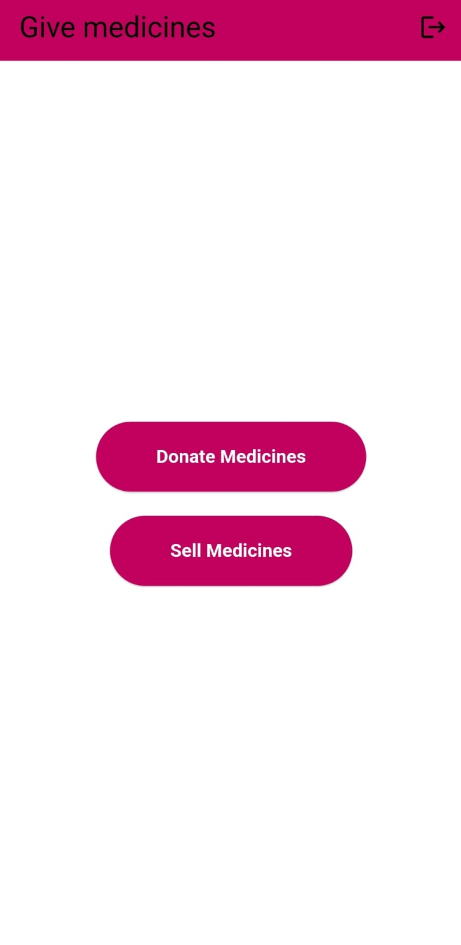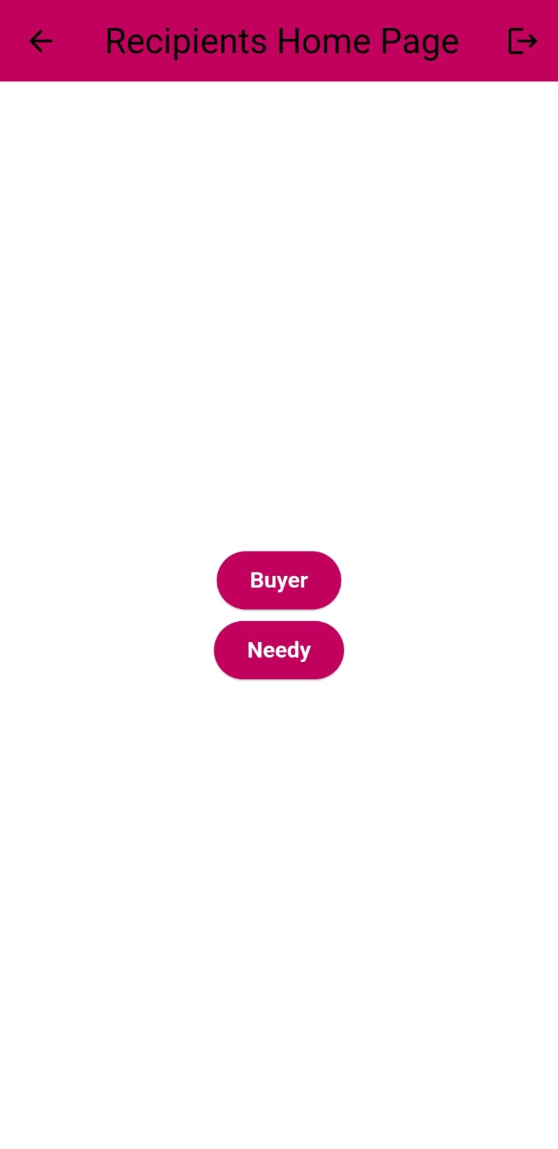
2. **Available medicines dashboard:**

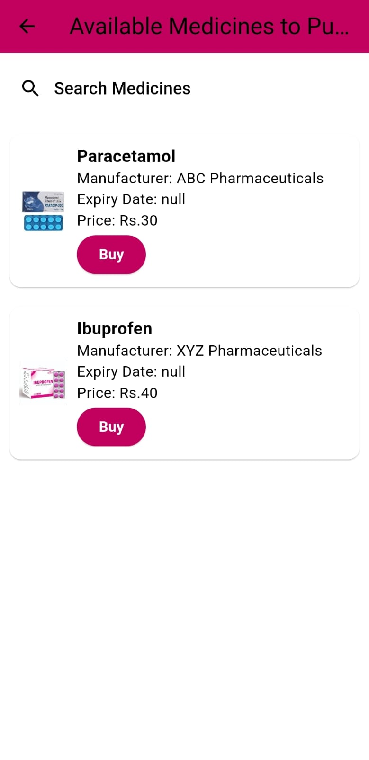

1. **Buy medicine at ML predicted price:**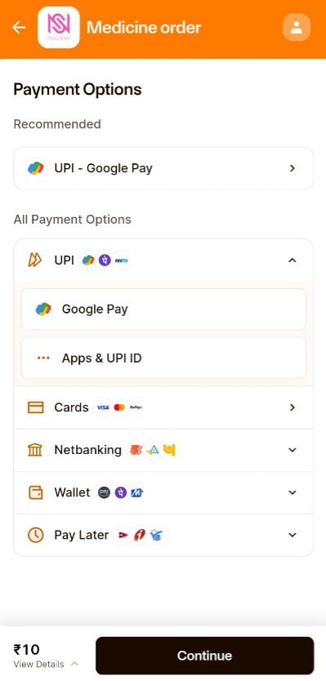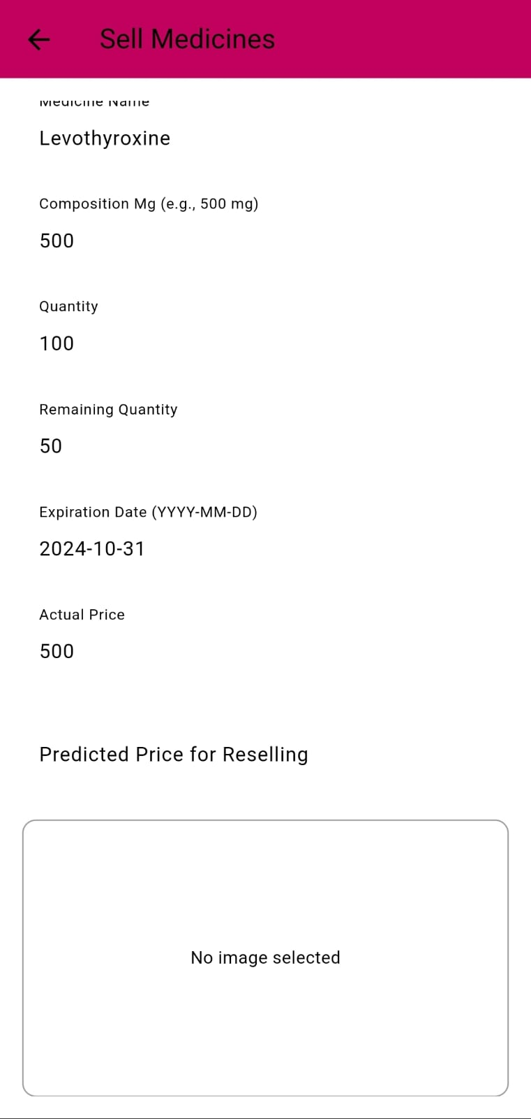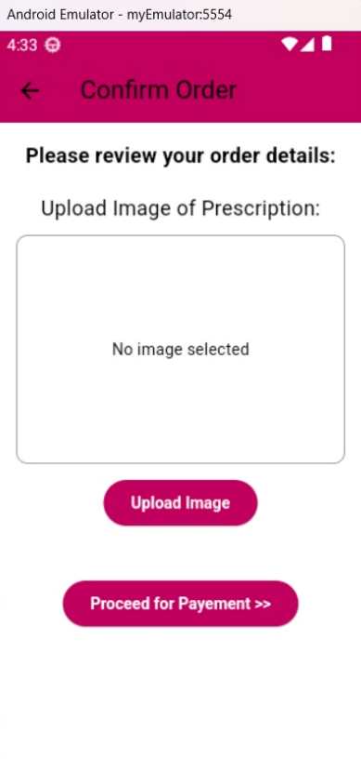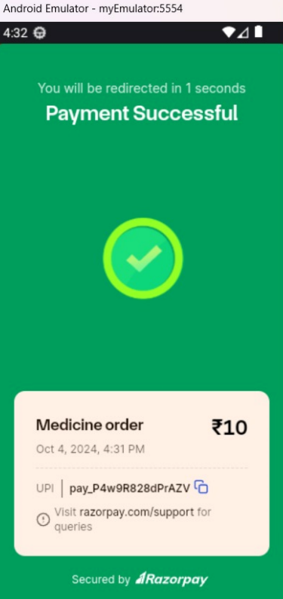
2. **Apply for free medicines:**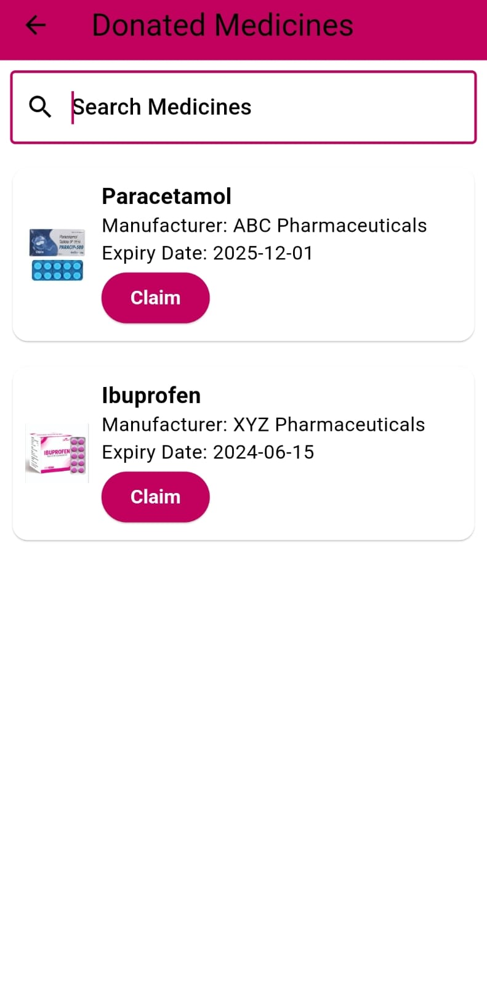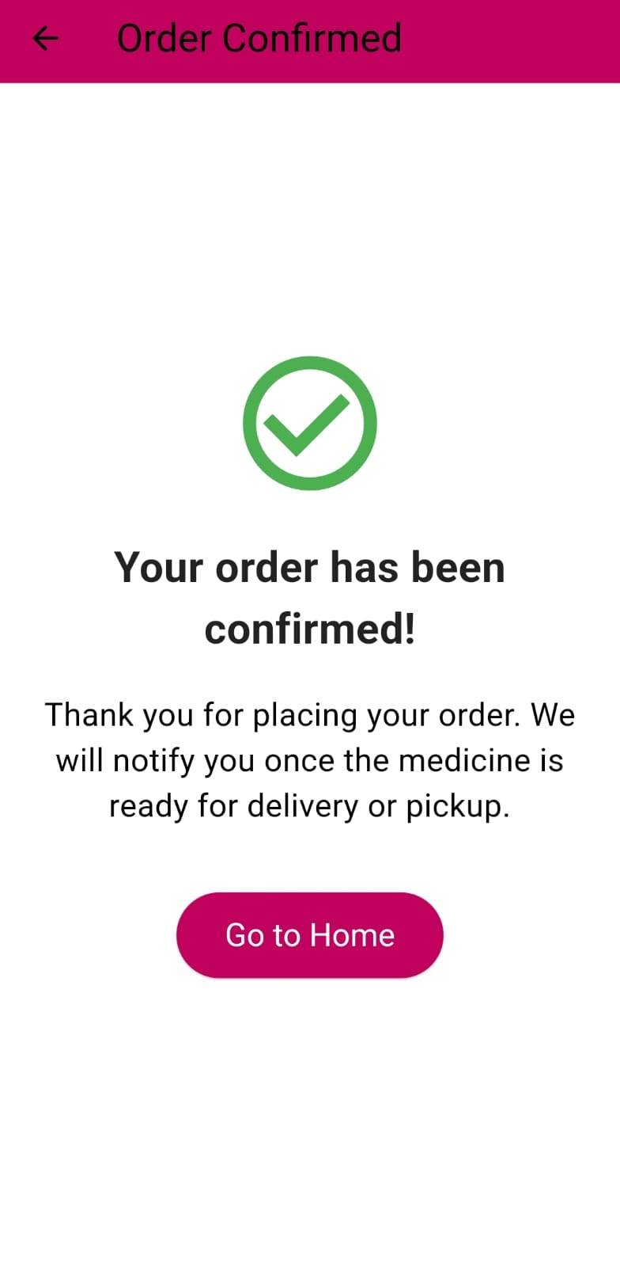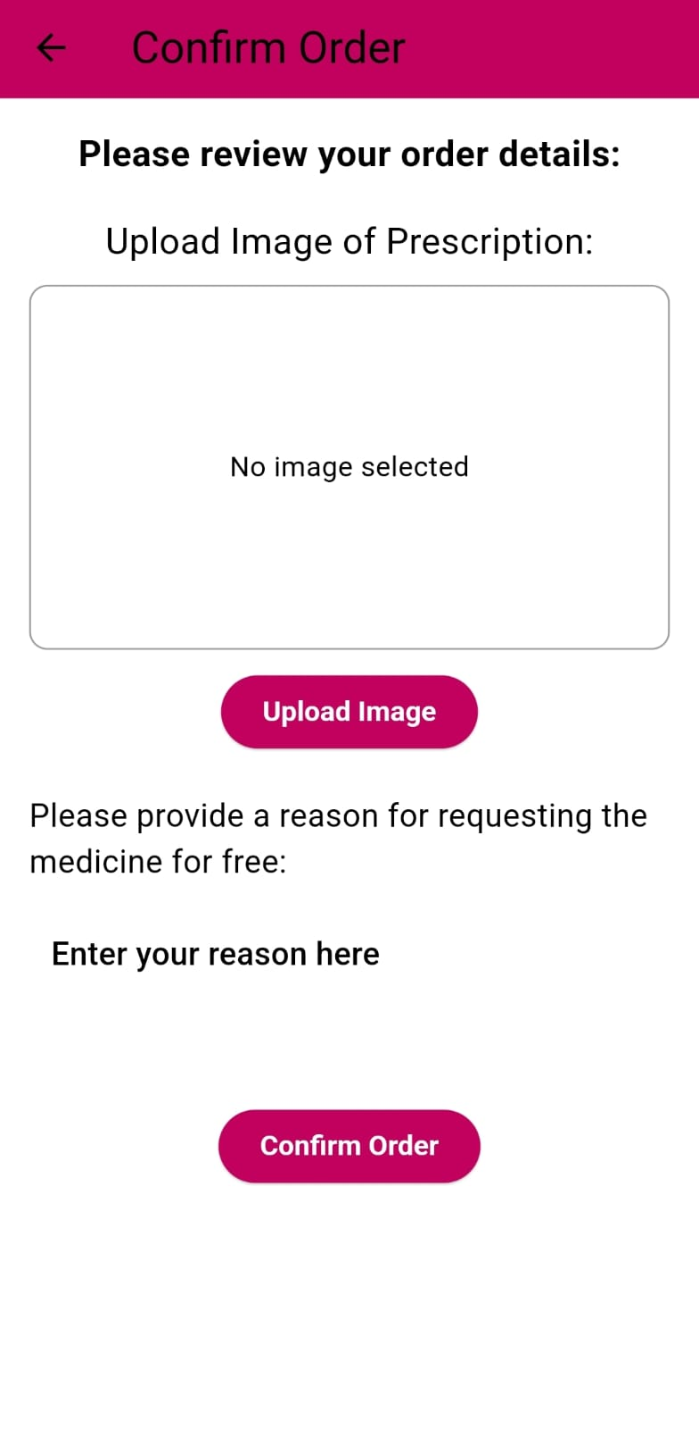
3. **NGO managed Marketplace:**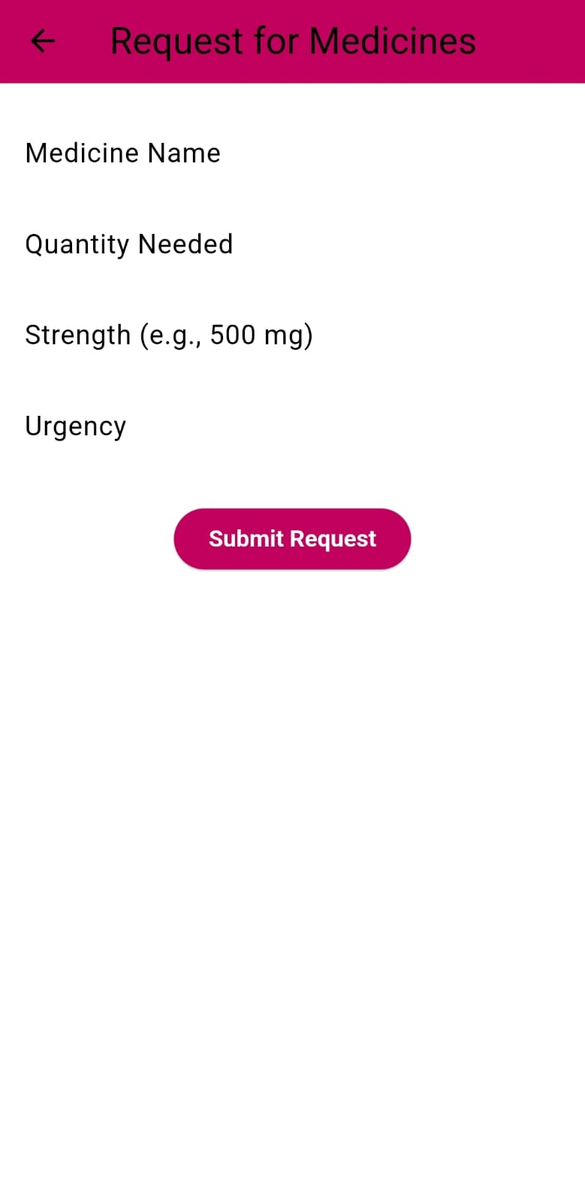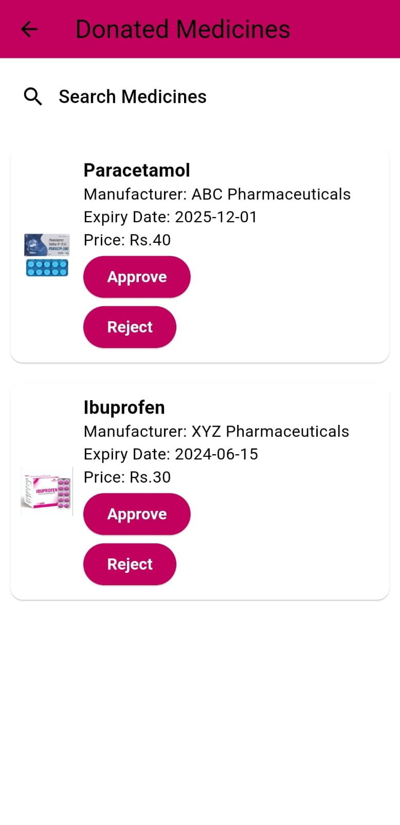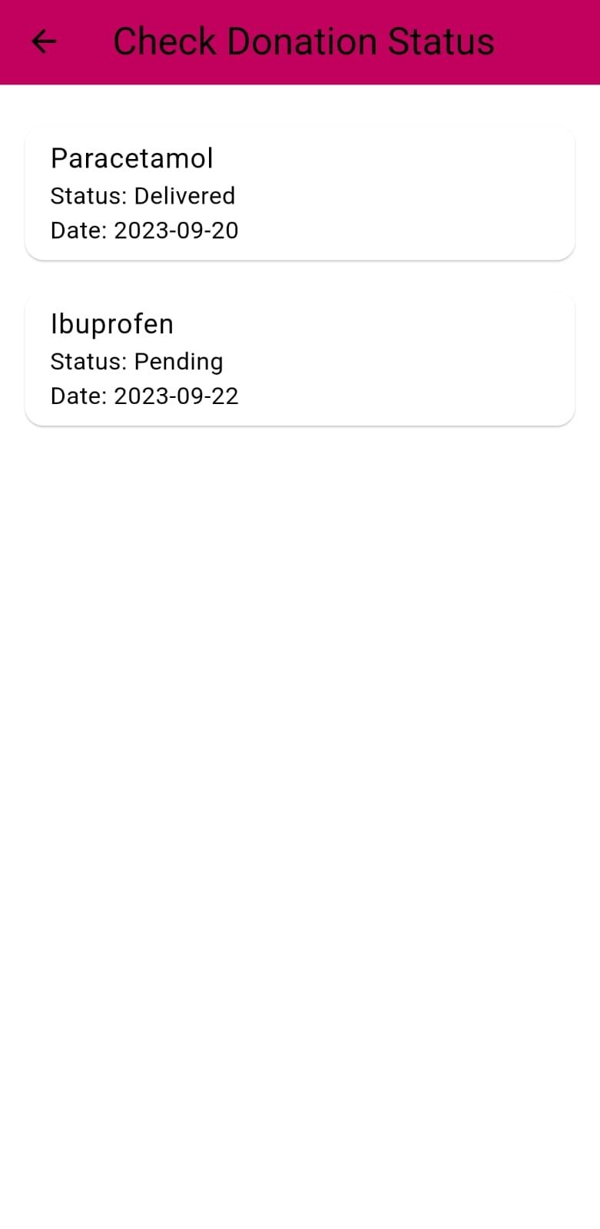

**Future Work Plan:**

1. **Health Points Program:** Establish a health points program that rewards users for donating surplus medications. Users can accumulate points that can be exchanged for discounts on future medication purchases via the app. This initiative promotes donations and encourages user involvement by providing concrete rewards for participation.
2. **Dashboard Creation:** Develop dashboards for the users to see their profiles as well as transaction history.
3. **Medicinal Insights:** Offer visual data regarding medication availability and market trends in pharmaceuticals to understand trends in the medicine market.

**3.6 Conclusion and Future Scope**

**Conclusion:**

The ngo marketplace project effectively utilizes machine learning to optimize the redistribution of leftover medicines, significantly reducing waste while improving access to essential medications. This advanced approach not only enhances the efficiency of distribution but also ensures that critical medicines reach those in need, addressing a crucial gap in healthcare accessibility.

Collaborating with a reputable pharmacy, the ngo upholds high safety standards, establishing the project as a model for innovative and ethical medication management. By promoting fair pricing and efficient distribution, the platform champions sustainability and affordability, making a meaningful impact on responsible resource use and fostering a more equitable healthcare system.

**Future Scope of the Project:**

* **Expansion of Partnerships**: Collaborate with more pharmacies and healthcare organizations to increase medicine availability.
* **Geographical Reach:** Scale the project to new regions or countries, adapting to local healthcare needs.
* **Integration of Telehealth Services**: Connect patients with healthcare providers to facilitate prescriptions and consultations.
* **Enhanced Data Analytics:** Utilize advanced analytics to predict medication demand and improve inventory management.
* **Policy Advocacy:** Engage in efforts to influence policies on pharmaceutical waste management and ethical practices in healthcare.

**REFERENCES:**

**[1].S. Shukla, Y. Kharde, G. N. Mandala, S. Bhikaji Jadhav and G. S. Doguparthy, "Optimization of Dynamic Pricing in E-Commerce Platform with Demand Side Management using Fuzzy Logic System,"** 2023 Second International Conference on Augmented Intelligence and Sustainable Systems (ICAISS), Trichy, India, 2023, pp. 848-853, doi: 10.1109/ICAISS58487.2023.10250726.

**[2]. Chong, Kah & Rajiah, Kingston & Chong, David & Mari Kannan, Maharajan. (2022). Management of Medicines Wastage, Returned Medicines and Safe Disposal in Malaysian Community Pharmacies:** A Qualitative Study. Frontiers in Medicine. 9. 884482. 10.3389/fmed.2022.884482.

**[3]. N. A. Satrio et al., "Implementation Augmented Intelligence on Drug Inventory Management Forecasting,"** 2022 International Electronics Symposium (IES), Surabaya, Indonesia, 2022, pp. 564-569, doi: 10.1109/IES55876.2022.9888302.

**[4]. Luo, Yufeng & Wan, Zhong. (2022). An optimal system of recycling unwanted medicines by sustainable synergy of drugmakers, drugstores, customers and governments.** Journal of Cleaner Production. 376. 134304. 10.1016/j.jclepro.2022.134304.

**[5].A. Mostofi and V. Jain, "Inventory Management and Control Of Deteriorating Pharmaceutical Products sing Industry 4.0,"** 2021 IEEE 8th International Conference on Industrial Engineering and Applications (ICIEA), Chengdu, China, 2021, pp. 394-400, doi: 10.1109/ICIEA52957.2021.9436744.

**[6] M. Debe, K. Salah, R. Jayaraman and J. Arshad, "Blockchain-Based Verifiable Tracking of Resellable Returned Drugs,"** in IEEE Access, vol. 8, pp. 205848-205862, 2020, doi: 10.1109/ACCESS.2020.3037363.

**[7]. Bashatah A, Wajid S. Knowledge and Disposal Practice of Leftover and Expired Medicine: A Cross-Sectional Study from Nursing and Pharmacy Students' Perspectives.** Int J Environ Res Public Health. 2020 Mar 20;17(6):2068. doi: 10.3390/ijerph17062068. PMID: 32244973; PMCID: PMC7142560.